//bill calculator

#include<stdio.h>

void main()

{

char product_name[20];

int quantity;

float price,bill_amount ,discount=0,net_amount;

printf("enter the product name\n");

scanf("%s",product_name);

printf("quantity:");

scanf("%d",&quantity);

printf("price:");

scanf("%f",&price);

bill_amount=quantity*price;

if(bill_amount>=5000)

discount=bill_amount*0.15;

net_amount=bill_amount-discount;

printf("Bill Amount\t:%10.2f\n",bill_amount);

printf("discount\t:%10.2f\n",discount);

printf(" \t================\n");

printf("Net amount\t:%10.2f\n",net_amount);

printf(" \t================\n");

}

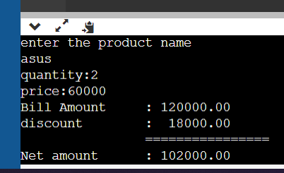

//bill calculator

#include<stdio.h>

void main()

{

char product_name[20];

int quantity;

float price,bill_amount ,discount=0,net_amount;

printf("enter the product name\n");

scanf("%s",product_name);

printf("quantity:");

scanf("%d",&quantity);

printf("price:");

scanf("%f",&price);

bill_amount=quantity*price;

if(bill_amount>=50000)

discount=bill_amount*0.20;//20% discount

else

discount=bill_amount*0.10;//10%discount

net_amount=bill_amount-discount;

printf("Bill Amount\t:%10.2f\n",bill_amount);

printf("discount\t:%10.2f\n",discount);

printf(" \t================\n");

printf("Net amount\t:%10.2f\n",net_amount);

printf(" \t================\n");

}

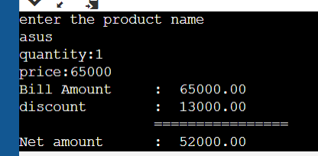

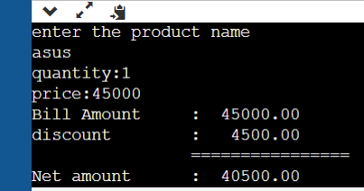

//no is divisible by 2 and 3(nested if)

#include<stdio.h>

void main()

{

int x;

printf("enter the number\n");

scanf("%d",&x);

if(x%2==0)

{

if(x%3==0)

{

printf("number is divisilbe by 2 and 3\n");

}

else

{

printf("number is divisilbe by 2 but not 3\n");

}

}

else if(x%3==0)

{

printf("number is divisilbe by 3 but not 2\n");

}

else

printf("number is not divisilbe by 2 and 3\n");

}

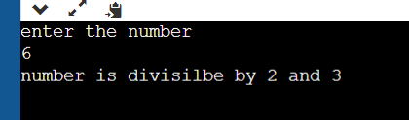

//grade system

#include<stdio.h>

void main()

{

float cgpa;

printf("enter the cgpa\n");

scanf("%f",&cgpa);

if(cgpa<0||cgpa>10)

printf("invalid");

else if(cgpa>=9&&cgpa<=10)

printf("Grade \"o\"\n");

else if (cgpa>=8&&cgpa<=8.99)

printf("Grade \"A\"\n");

else if (cgpa>=8&&cgpa<=8.99)

printf("Grade \"A\"\n");

else if (cgpa>=7&&cgpa<=7.99)

printf("Grade \"B\"\n");

else if (cgpa>=6&&cgpa<=6.99)

printf("Grade \"C\"\n");

else if (cgpa>=5&&cgpa<=5.99)

printf("Grade \"D\"\n");

else

printf("\"NO\" Grade\n");

}

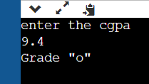

//switch case

#include<stdio.h>

void main()

{

int day;

printf("enter the number\n");

scanf("%d",&day);

switch(day)

{

case 1: printf("BOSS it,s MONDAY . concentrate on \"work\"");

break;

case 2 ...4: printf("Still it's week day only"); // or case 2:case3:case4:

break;

case 5: printf("It's Friday .Get ready for weekedn");

break;

case 6 ...7: printf("Enjoy the holidays");

break;

default : printf("invalid day") ;

}

}

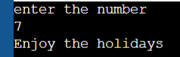

//simple calci

#include<stdio.h>

#include<math.h>

void main()

{

double n1,n2,result=0;

char op;

printf("enter the expression\n");

scanf("%lf %c %lf",&n1,&op,&n2);

switch(op)

{

case '+':result=n1+n2;

break;

case '-':result=n1-n2;

break;

case '/':result=n1/n2;

break;

case '%':result=fmod(n1,n2);

break;

case '*':result=n1*n2;

break;

default:printf("invalid operator!!");

return ;

}

printf("%g %c %g = %g",n1,op,n2,result); //%g zero will be removed

} ("%d %c %d = %d",n1,op,n2,result);

}

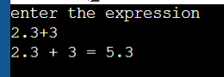

#include<stdio.h>

void main()

{

int i,n;

scanf("%d",&n);

for(i=n;i>0;i--)

if(i%2!=0)

printf("%d\n",i);

}

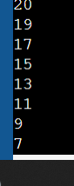

#include<stdio.h>

void main()

{

int i,n,sum=0;

scanf("%d",&n);

for(i=1;i<=n;i++){

// printf("%d+",i);

sum=sum+i;

}

printf("=%d\n",sum);

}

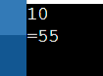

#include<stdio.h>

void main()

{

int i,n,result=1;

scanf("%d",&n);

for(i=1;i<=n;i++){

// printf("%d+",i);

result=result*i;

}

printf("%d\n",result);

}

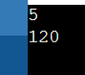

//reverseing the number

#include<stdio.h>

void main(){

int rem,result=0,n,r;

printf("enter number ");

scanf("%d",&n);

while(n>0)

{

r=n%10;

result=result*10+r;

n=n/10;

}

printf("reveresed number is %d\n",result);

}

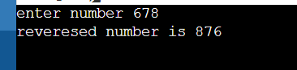

//palindrome

#include<stdio.h>

void main(){

int rem,result=0,n,r,original;

printf("enter number ");

scanf("%d",&n);

original=n;

while(n>0)

{

r=n%10;

result=result*10+r;

n=n/10;

}

if(original==result)

{

printf("number is palindrome");

}

else

{

printf("number is not palindrome");

}

}

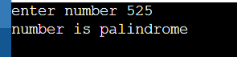

while(result=result*10+n%10,n/=10); //if n becomes 0 then condition becomes false loop terminates

printf("%s",original==result?"yes":"no");

}

//do

#include<stdio.h>

int main()

{

int n;

char choice;

do{

scanf("%d",&n);

if(n>0)

printf("number is positive\n");

else if(n<0)

printf("negative\n");

else

printf("zero\n");

printf("want to check more [y]es or[n]o\n");

scanf("%c",&choice);

scanf("%c",&choice);

}while(choice=='y'||choice=='Y');

return 0;

}

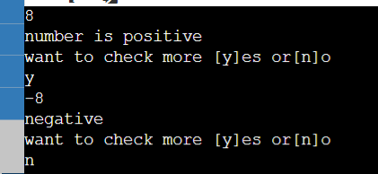

//break statements

#include<stdio.h>

int main()

{

for(int i=1;i<=10;i++)

{

if(i%4==0)

break;

printf("%d",i);

}

return 0;

}



//break statements

#include<stdio.h>

int main()

{

for(int i=1;i<=10;i++)

{

if(i%4)

break;

printf("%d",i);

}

return 0;

}

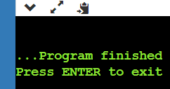 no output since initially condition is fasle

//continue statements

#include<stdio.h>

int main()

{

for(int i=1;i<=10;i++)

{

if(i%4==0)

continue ;

printf("%d ",i);

}

return 0;

}

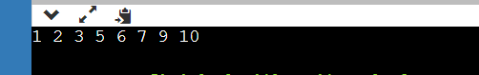

//goto statements

#include<stdio.h>

int main()

{

for (int j=1;j<5;j++){

for(int i=1;i<=10;i++)

{

if(i%4==0)

goto exit;

printf("%d ",i);

}

}

exit: //lable name : syntax "lable"

return 0;

}

* Make a table for the required out put

//nested loop to print table kind of output

#include<stdio.h>

int main()

{

for ( int i =1;i<=5;i++) //row

{

for(int j=1;j<=5;j++)//column

{

printf("ashless ");

}

printf("\n");

}

return 0;

}

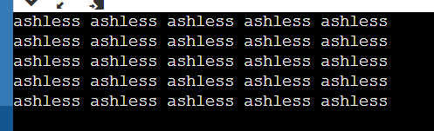

//nested loop to print table kind of output

#include<stdio.h>

int main()

{

for ( int i =1;i<=5;i++) //row

{

for(int j=1;j<=i;j++)//column

{

printf("ashless ");

}

printf("\n");

}

return 0;

}

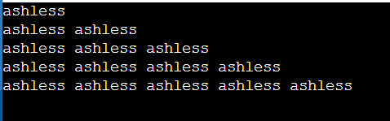

//nested loop to print table kind of output

#include<stdio.h>

int main()

{

for ( int i =1;i<=5;i++) //row

{

for(int j=1;j<=i;j++)//column

{

printf("%d ",j);

}

printf("\n");

}

return 0;

}

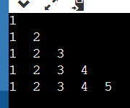

// program to print the pattern

// input 5

/*out put

1

2 3

4 5 6

7 8 9 10

11 12 13 14 15

*/

#include<stdio.h>

void main()

{

int n,k=1;

scanf("%d",&n);

for (int r=1;r<=n;r++)

{

for(int c=1;c<=r;c++)

{

printf("%d\t",k);

k=k+1;

}

printf("\n");

}

}

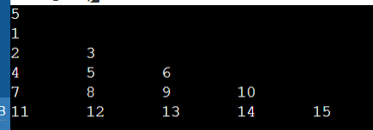

#include<stdio.h>

int main()

{

int n;

scanf("%d",&n);

for (int r=n;r<=1;r--)

{

for(int c=1;c<=r;c++)

{

printf("%d\t",c);

}

printf("\n");

}

return 0;

}

#include<stdio.h>

int main()

{

int n;

scanf("%d",&n);

for (int r=n;r>=1;r--)

{

for(int c=r;c<=r && c>0;c--)

{

printf("%d\t",c);

}

printf("\n");

}

return 0;

}

#include<stdio.h>

int main()

{

int n;

scanf("%d",&n);

for (int r=n;r>=1;r--)

{

//printing space

for(int c=1;c<=n-r;c++)

{

printf(" ");

}

for(int c=r ;c>=1;c--){

printf("%d",c);

}

printf("\n");

}

return 0;

}

// row number

/* 5 4 3 2 1 5

4 3 2 1 4

3 2 1 3

2 1 2

1. 1 */

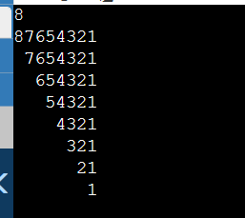

#include<stdio.h>

int main()

{

int n;

scanf("%d",&n);

for (int r=n;r>=1;r--)

{

for(int c=1 ;c<=r;c++){

printf("%d",c);

}

//printing space

for(int c=1;c<=n-r;c++)

{

printf(" "); //double space

}

for(int c=r ;c>=1;c--){

printf("%d",c);

}

printf("\n");

}

return 0;

}

// row number

/* 1 2 3 4 5 5 4 3 2 1 5

1 2 3 4 4 3 2 1 4

1 2 3 3 2 1 3

1 2 2 1 2

1 1 1 */

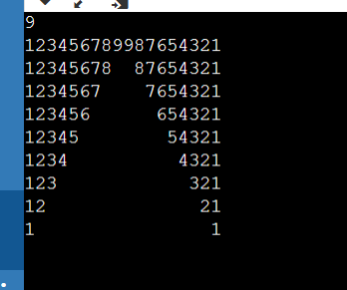

#include<stdio.h>

int main()

{

int n;

scanf("%d",&n);

for (int r=n;r>=1;r--)

{

for(int c=1 ;c<=r;c++){

printf("❤️");

}

//printing space

for(int c=1;c<=n-r;c++)

{

printf(" "); //double space

}

for(int c=r ;c>=1;c--){

printf("❤️️");

}

printf("\n");

}

return 0;

}

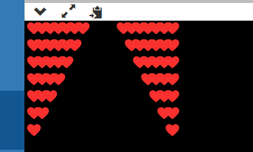

#include<stdio.h>

int main()

{

int n;

scanf("%d",&n);

for (int r=n;r>=1;r--)

{

for(int c=1 ;c<=r;c++){

printf("%c",c+64);

}

//printing space

for(int c=1;c<=n-r;c++)

{

printf(" "); //double space

}

for(int c=r ;c>=1;c--){

printf("%c",c+64);

}

printf("\n");

}

return 0;

}

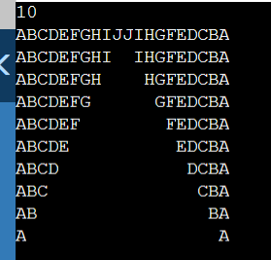

#include<stdio.h>

int main()

{

int n;

scanf("%d",&n);

for (int r=n;r>=1;r--)

{

for(int c=1 ;c<=r;c++){

printf("%c",c+64);

}

//printing space

for(int c=1;c<=n-r;c++)

{

printf(" "); //double space

}

for(int c=r ;c>=1;c--){

printf("%c",c+64);

}

printf("\n");

for (int r= 1;r<=n;r++)

{

for(int c=1 ;c<=r;c++){

printf("%c",c+64);

}

//printing space

for(int c=1;c<=n-r;c++)

{

printf(" "); //double space

}

for(int c=r ;c>=1;c--){

printf("%c",c+64);

}

printf("\n");

}

}

return 0;

}

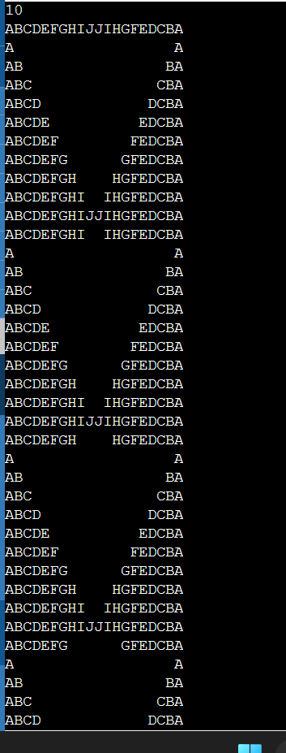

int main()

{

int n;

scanf("%d",&n);

for (int r= 1;r<=n;r++)

{

for(int c=1 ;c<=r;c++){

printf("%c",c+64);

}

//printing space

for(int c=1;c<=n-r;c++)

{

printf(" "); //double space

}

for(int c=r ;c>=1;c--){

printf("%c",c+64);

}

printf("\n");

}

for (int r=n;r>=1;r--)

{

for(int c=1 ;c<=r;c++){

printf("%c",c+64);

}

//printing space

for(int c=1;c<=n-r;c++)

{

printf(" "); //double space

}

for(int c=r ;c>=1;c--){

printf("%c",c+64);

}

printf("\n");

}

return 0;

}

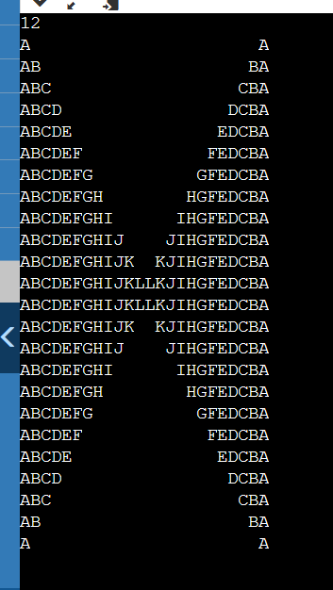

#include<stdio.h>

int main()

{

int n;

scanf("%d",&n);

for (int r=n;r>=1;r--)

{

for(int c=1 ;c<=r;c++){

printf("%c",c+64);

}

//printing space

for(int c=1;c<=n-r;c++)

{

printf(" "); //double space

}

for(int c=r ;c>=1;c--){

printf("%c",c+64);

}

printf("\n");

}

for (int r= 1;r<=n;r++)

{

for(int c=1 ;c<=r;c++){

printf("%c",c+64);

}

//printing space

for(int c=1;c<=n-r;c++)

{

printf(" "); //double space

}

for(int c=r ;c>=1;c--){

printf("%c",c+64);

}

printf("\n");

}

return 0;

}

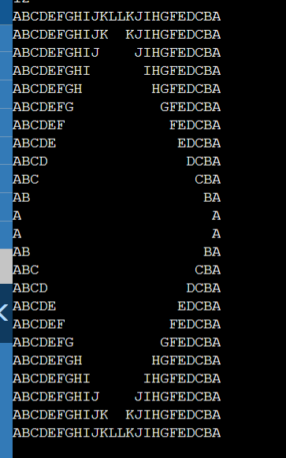

#include<stdio.h>

void main()

{

int n;

scanf("%d",&n);

for (int r=1;r<n;r++)

{

//printing space

for(int c=1;c<=n-r;c++)

{

printf(" "); //double space

}

for(int c=1 ;c<=r*2-1;c++){

printf("*");

}

printf("\n");

}

}

/*

1234* here number 1234 refers spaces

123***

12*****

1*******

*********

1*******

12*****

123***

1234*

*/

